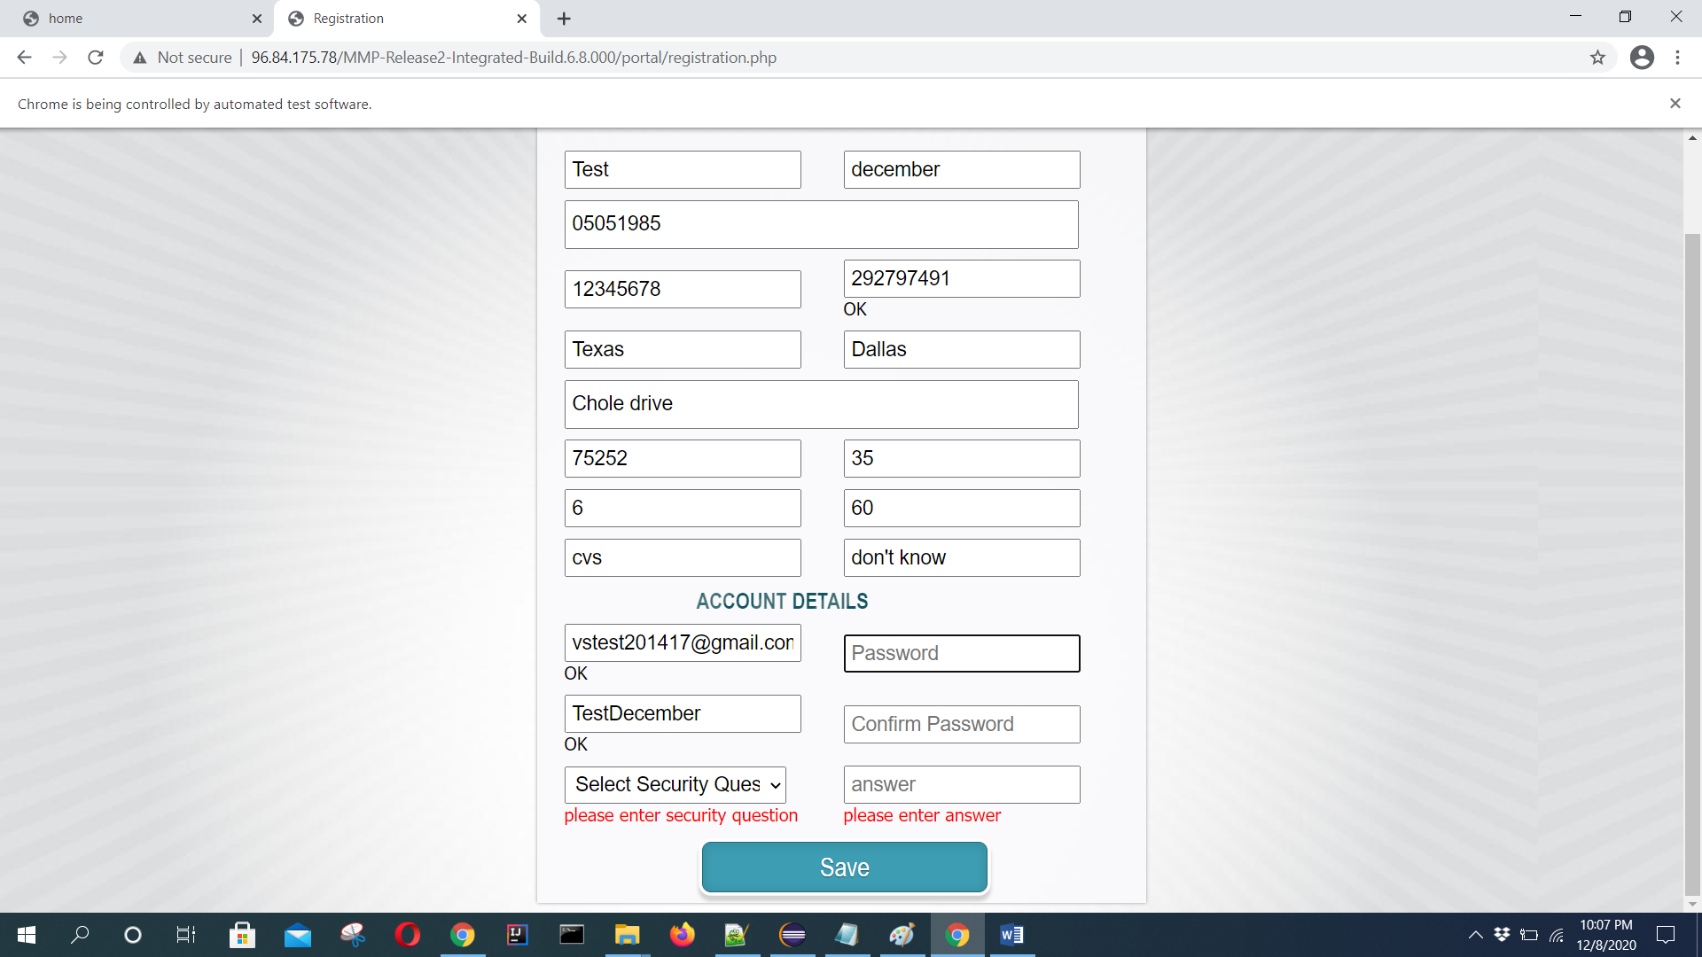

DecemberTest20$ [vstest201417@gmail.com](mailto:vstest201417@gmail.com)

What is your mother maiden name Lakshmi

//https://github.com/Ebazhanov/in-quiz-questions/blob/master/java/java-quiz.md

<https://www.oracle.com/technetwork/java/codeconventions-150003.pdf>

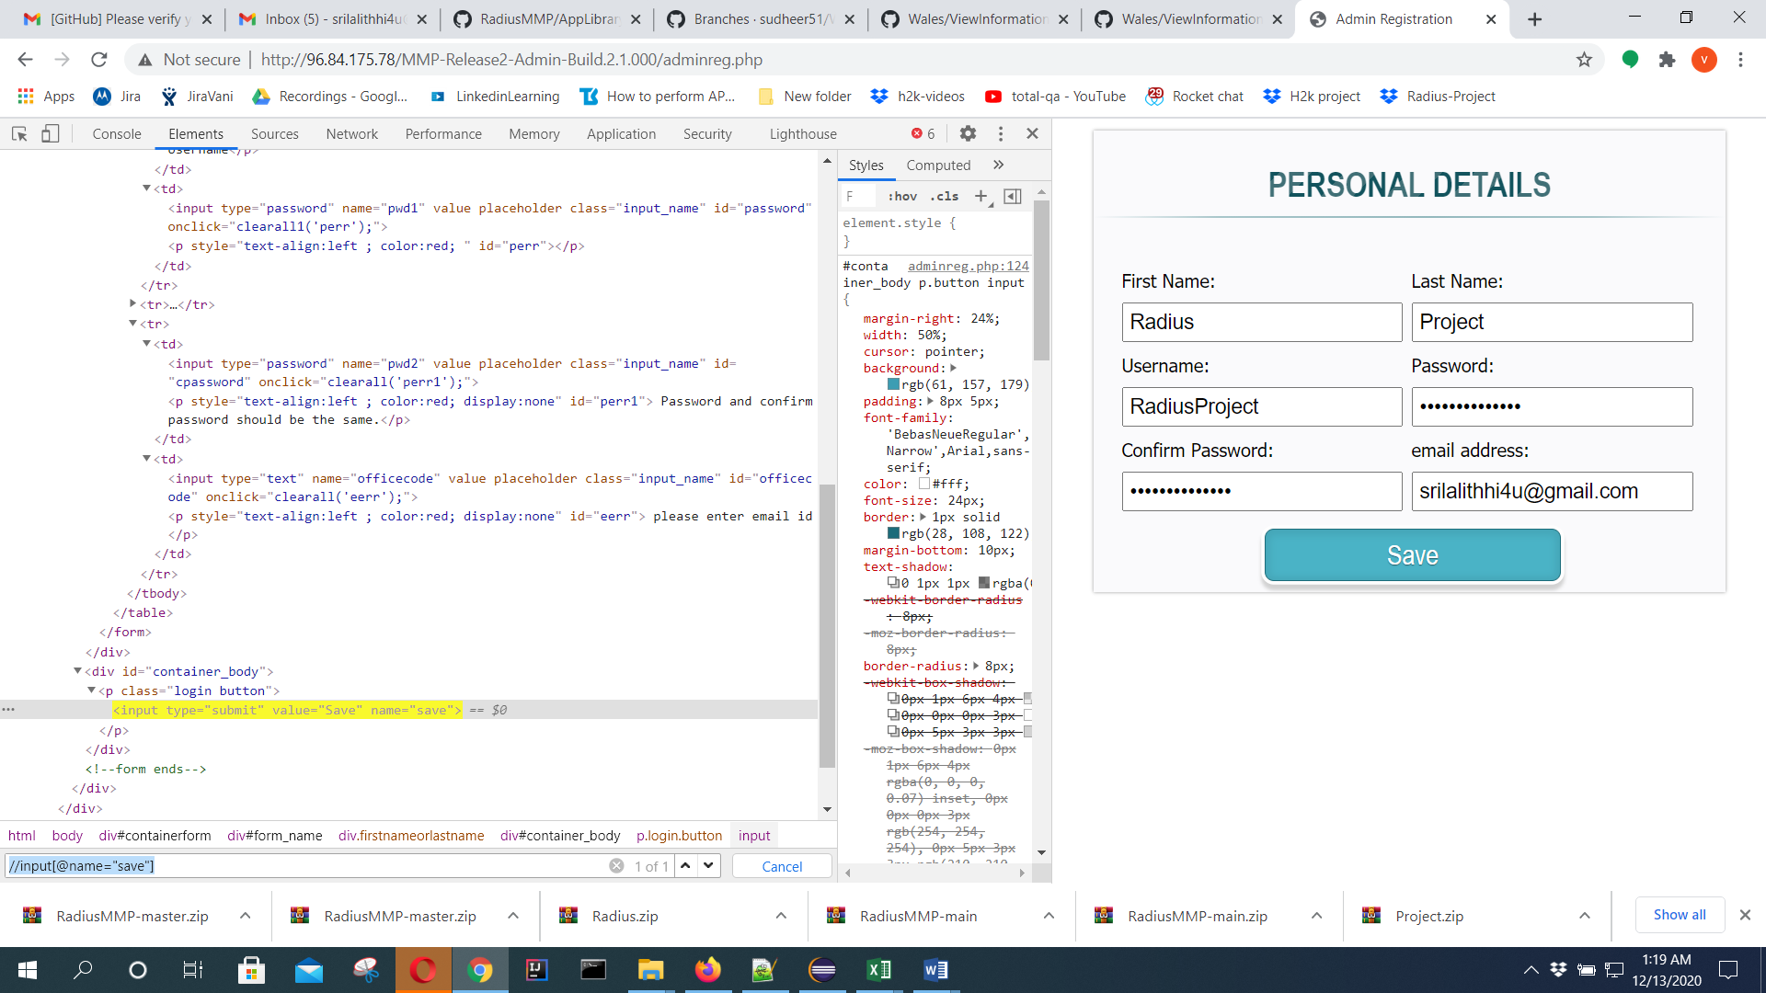

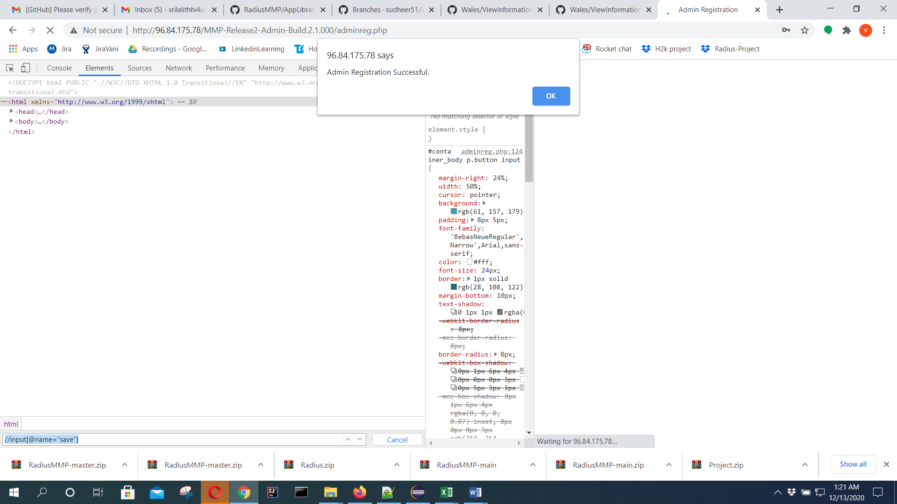

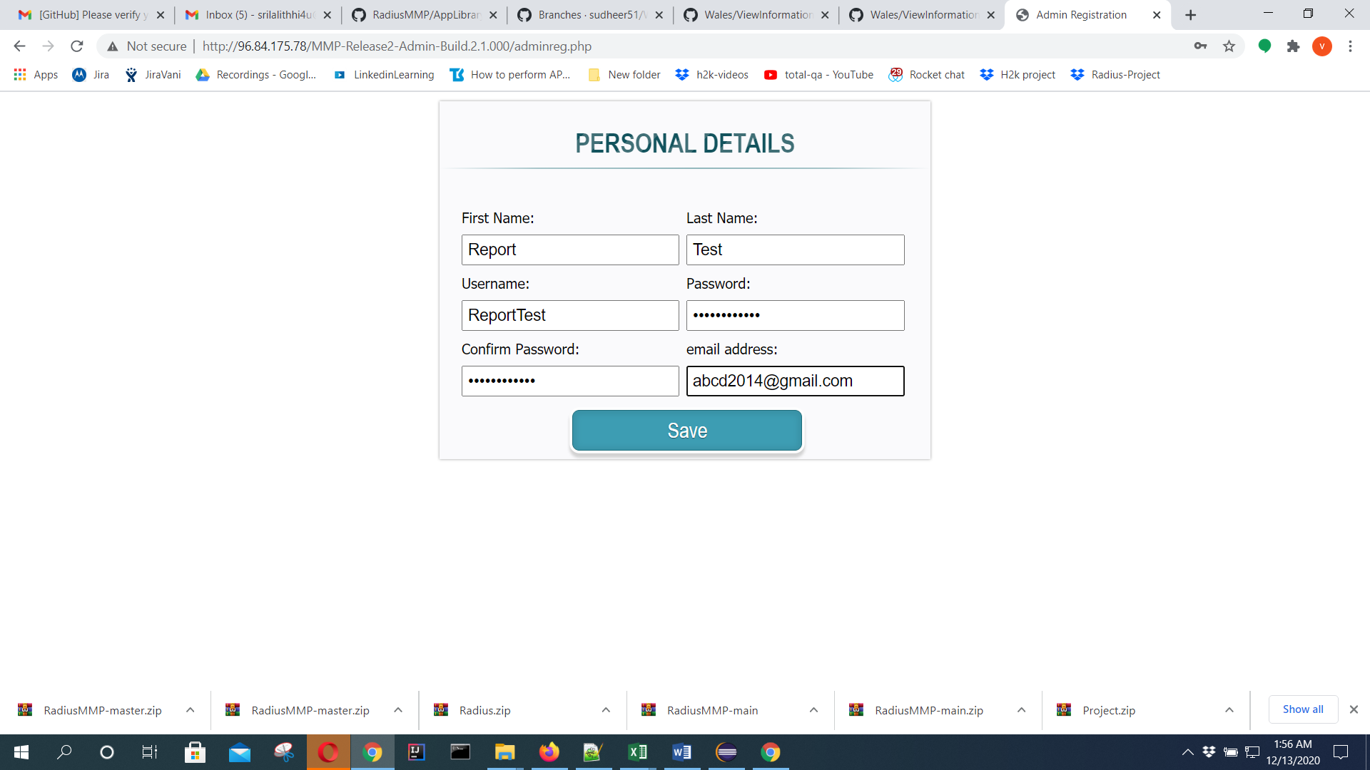

Reporttest20->login successful and with special character able to create admin user but not able to login

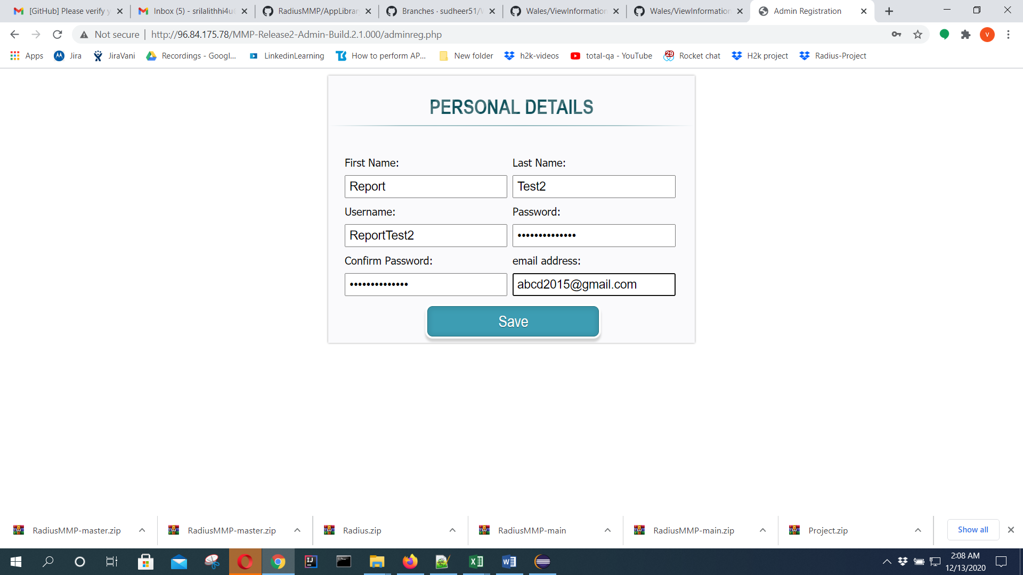

Reporttest2020 -pwd

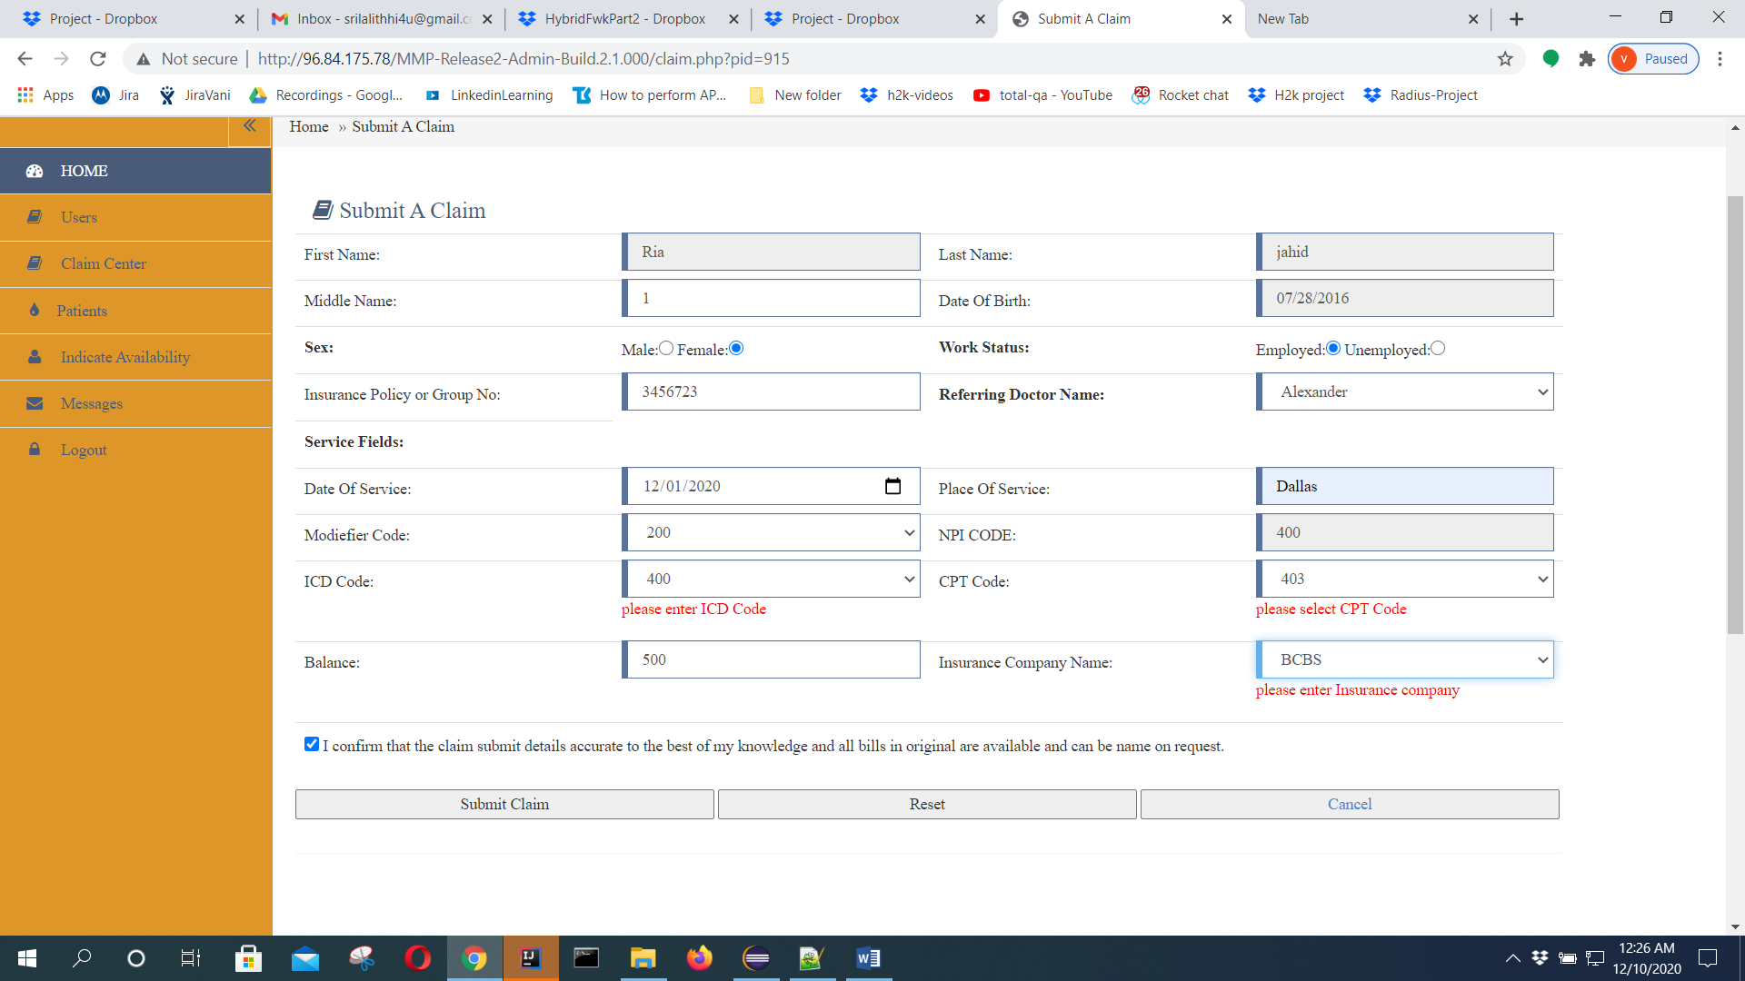

What is the modifier code and NPI CODE,ICD CODE,CPT CODE

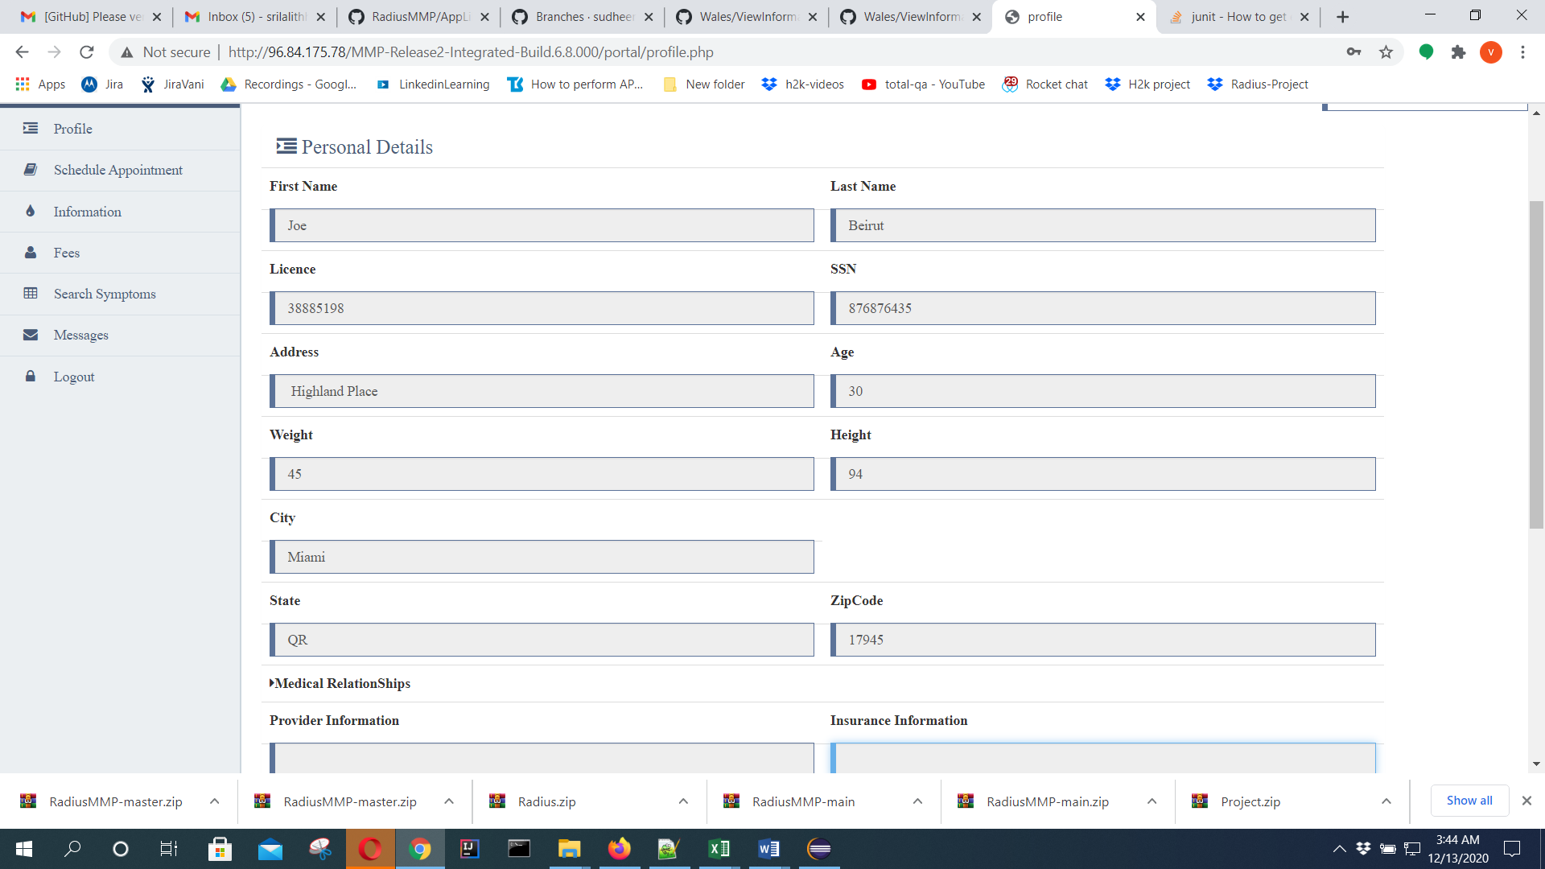

ssn 876876435

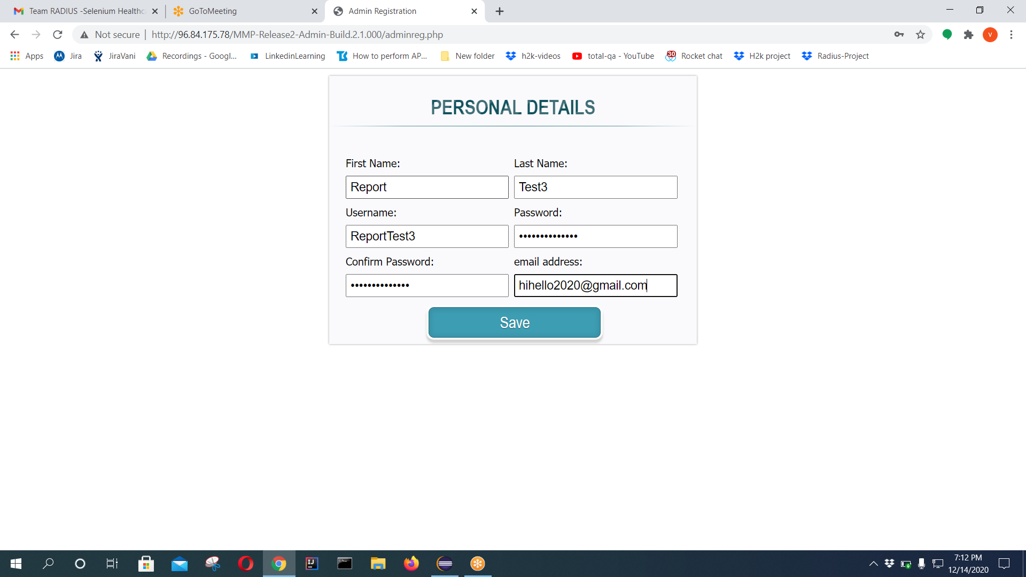

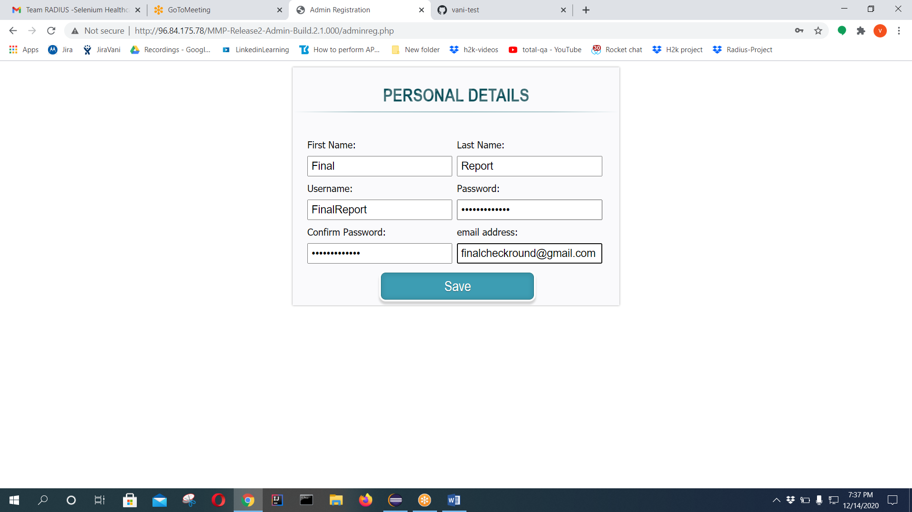

FinalReport - username

Finaltest2020- pwd

Doubttest5

ACCORDING TO BRD

1. First Name – required field
2. Last Name - required field
3. User Name - required field - max 10 characters without any special characters/blank spaces
4. Password - required field - max 6 characters with at least one numeric and one uppercase and should not include blank spaces.
5. Confirm Password - required field and match with the password field
6. Save Button

Pwd **Check1**

Username **Tycheck**

Firstname **Tuesday**

**Lname Check**

**Email** [**id-vstest201417@gmail.com**](mailto:id-vstest201417@gmail.com)

adminRegPage.enterFnameTextbox("Car");

adminRegPage.enterLnameTextbox("Parts");

adminRegPage.enterUnameTextbox("zia1");

adminRegPage.pwdTextbox("Zia12345");

adminRegPage.confirmPwdTextbox("Zia12345");

adminRegPage.emailidTextbox("vstest2014@gmail.com");

adminRegPage.saveButton();

**admin registration first name capital letter and last name capital letter**

**plz follow above format …then test case pass.**

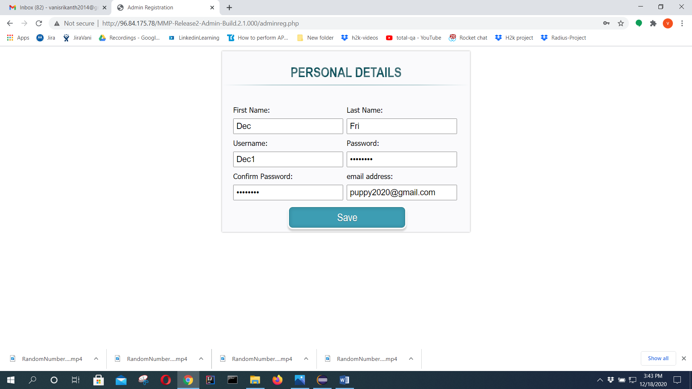

**Pwd for above test data ->Dec12345**

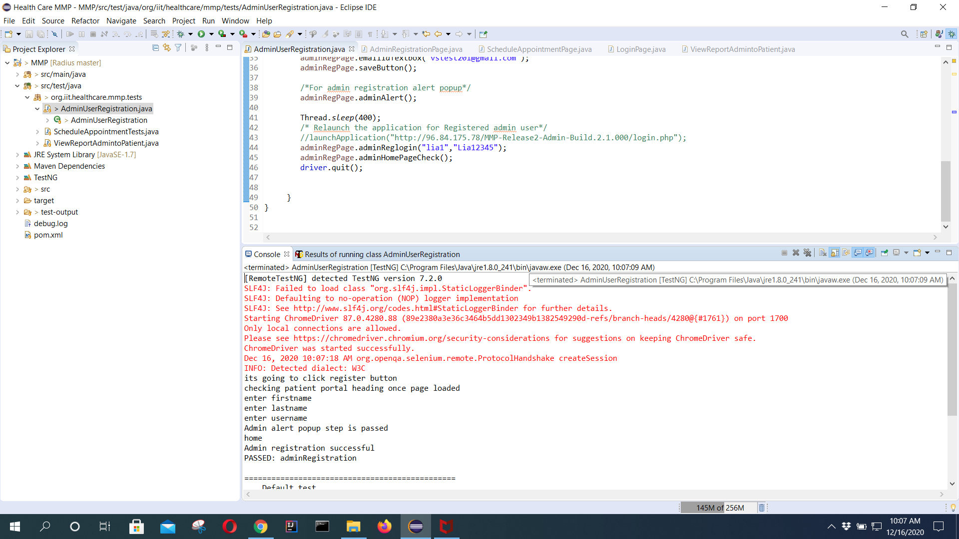

**First run its passed with the given data…**

System.***out***.println("enter firstname");

adminRegPage.enterFnameTextbox("Mars");

System.***out***.println("enter lastname");

adminRegPage.enterLnameTextbox("Part");

System.***out***.println("enter username");

adminRegPage.enterUnameTextbox("lia1");

adminRegPage.pwdTextbox("Lia12345");

adminRegPage.confirmPwdTextbox("Lia12345");

adminRegPage.emailidTextbox("vstest201@gmail.com");

adminRegPage.adminReglogin("lia1","Lia12345");

adminRegPage.adminHomePageCheck();

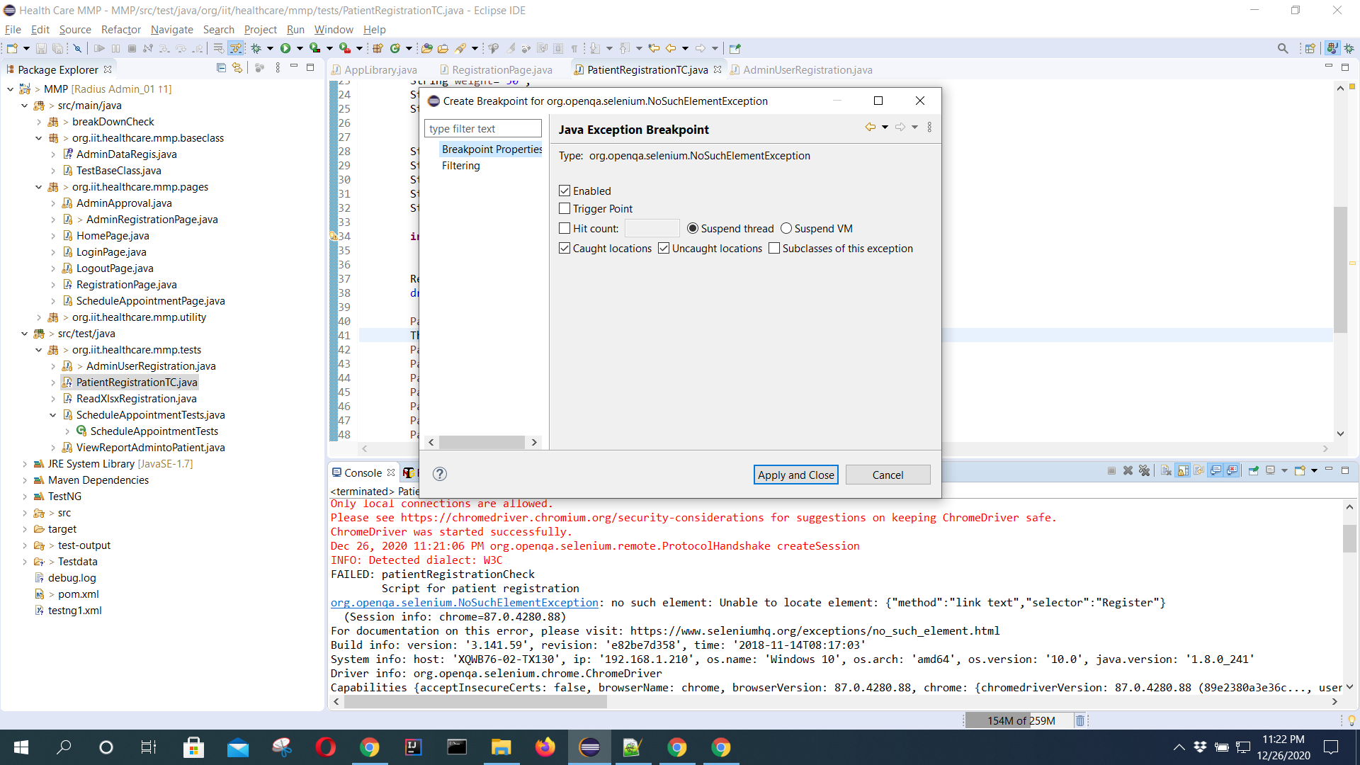

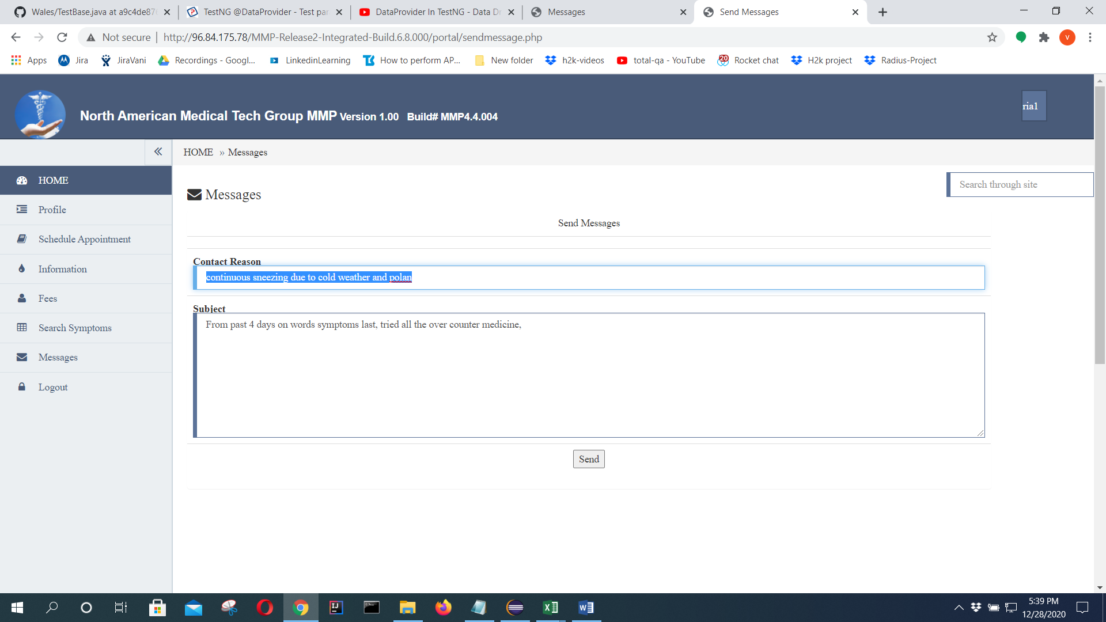

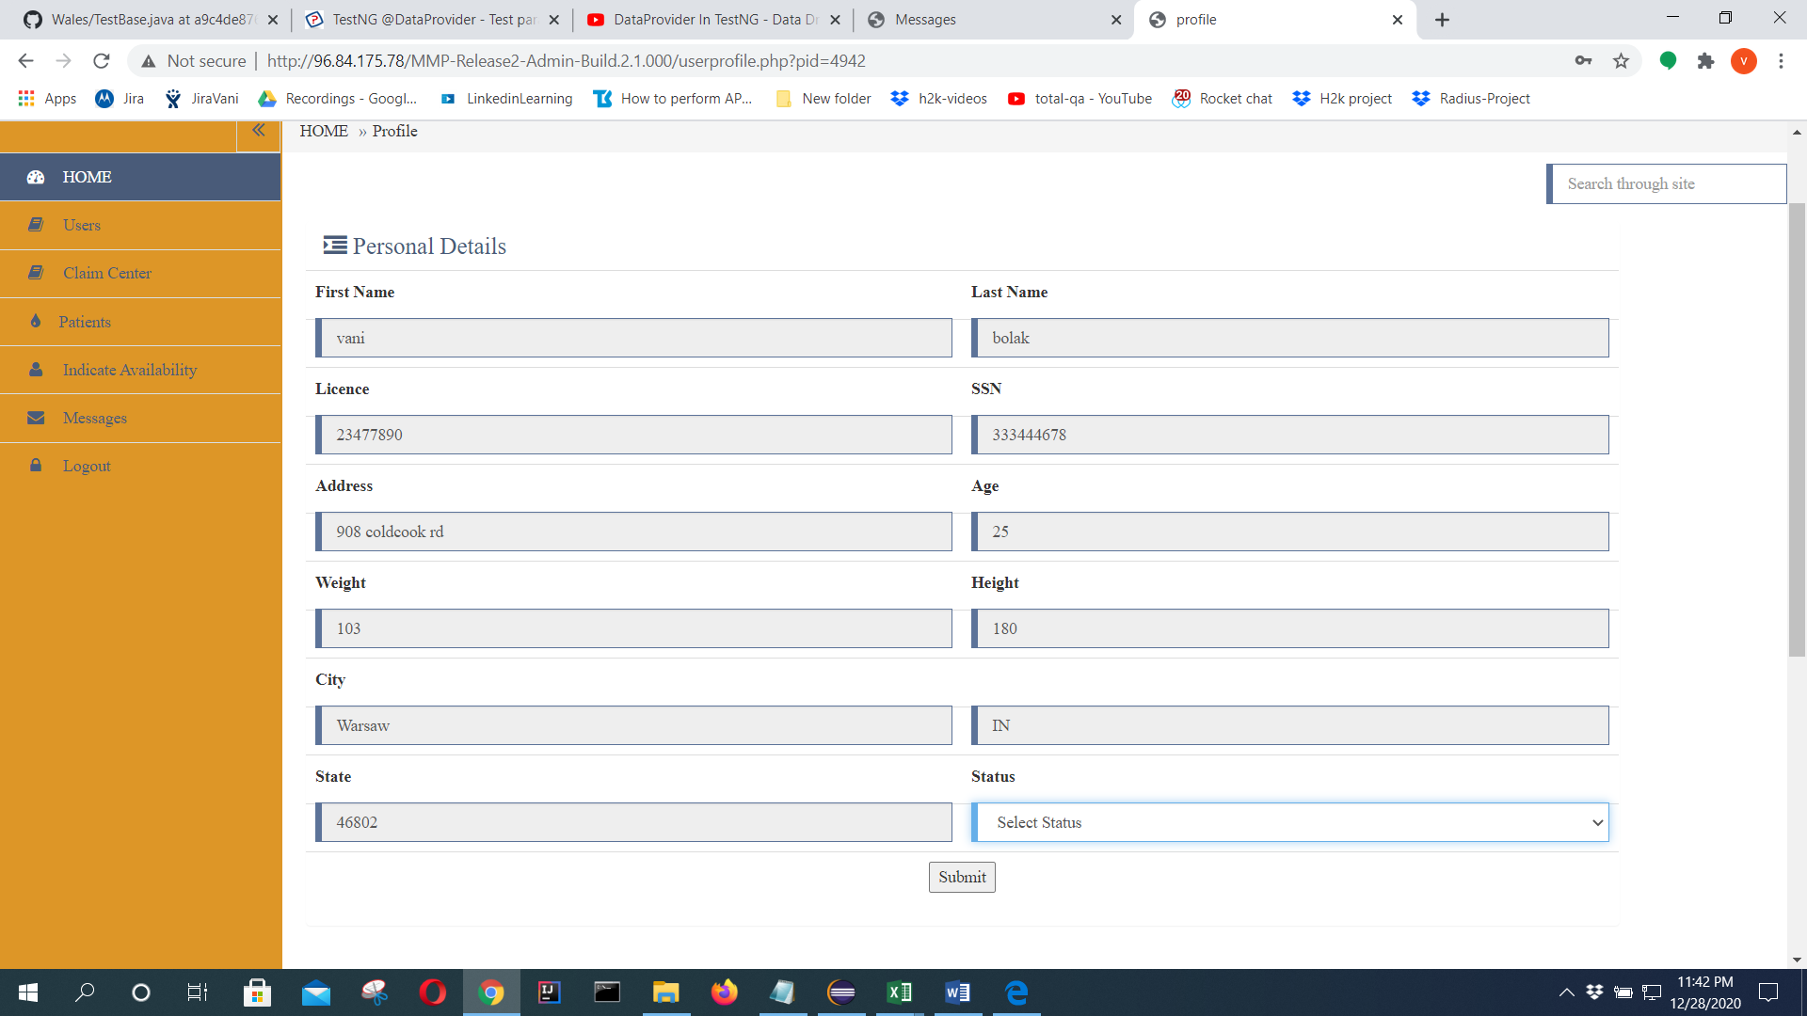

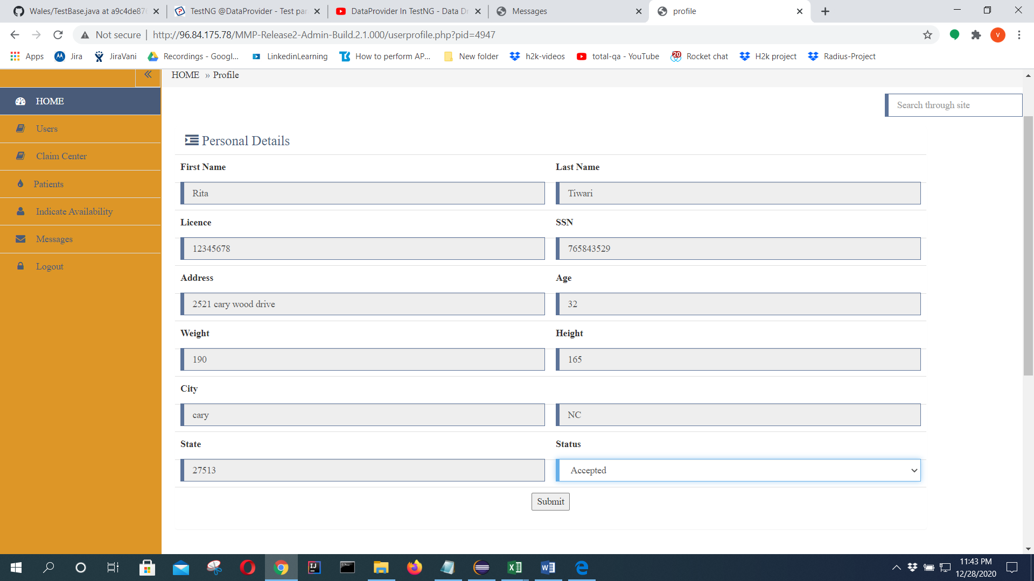

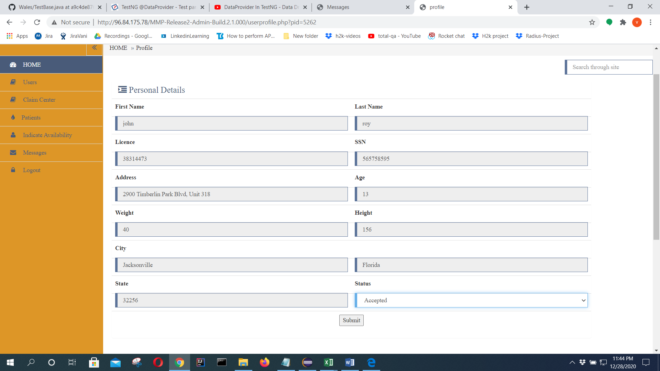

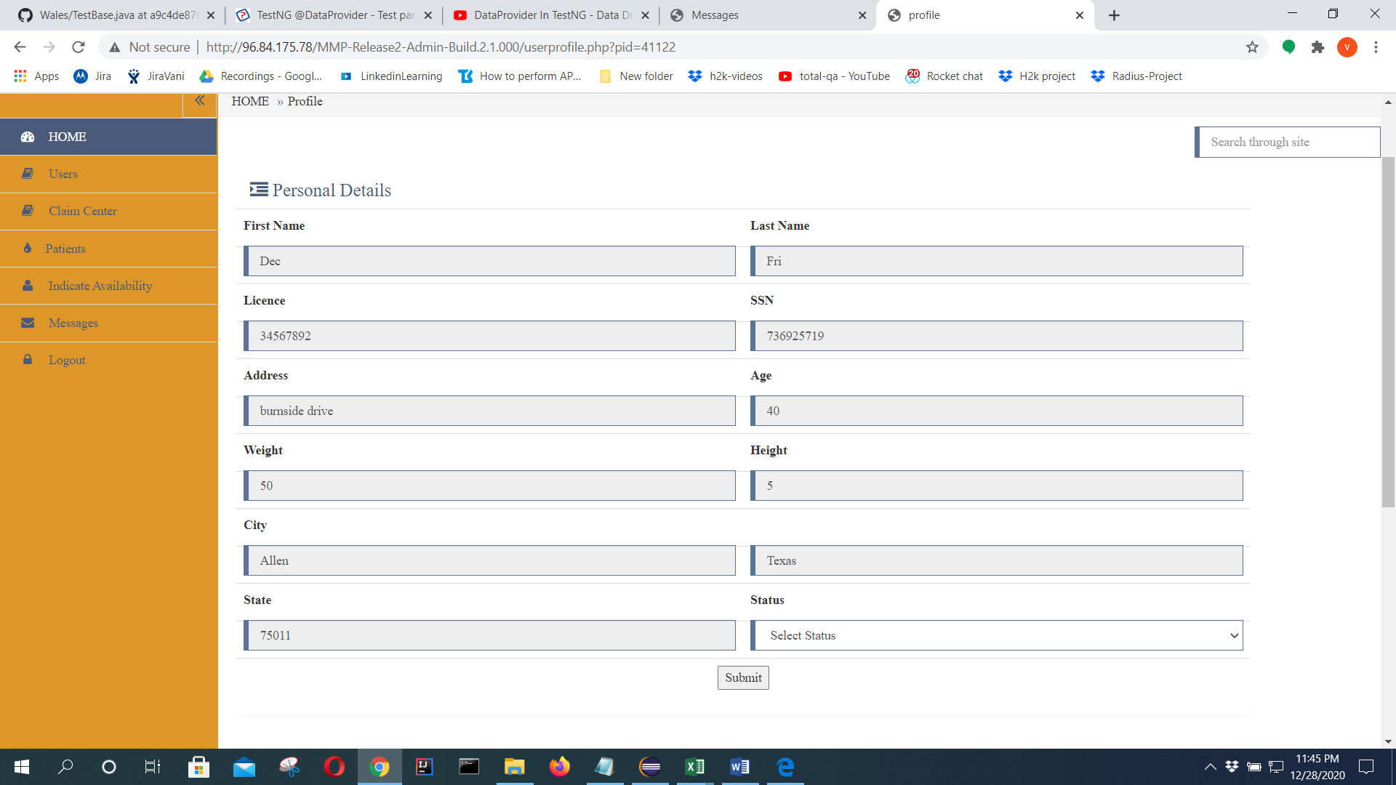

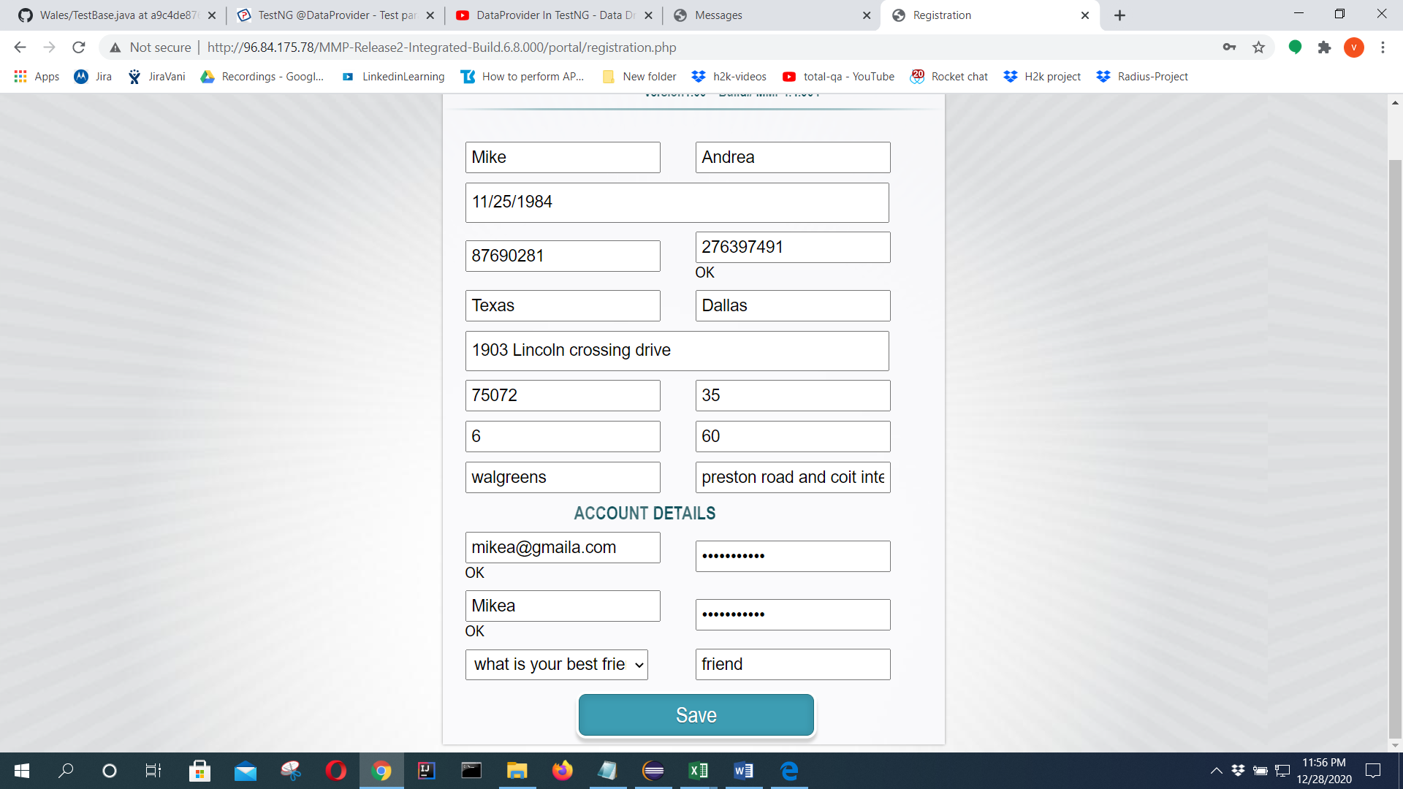

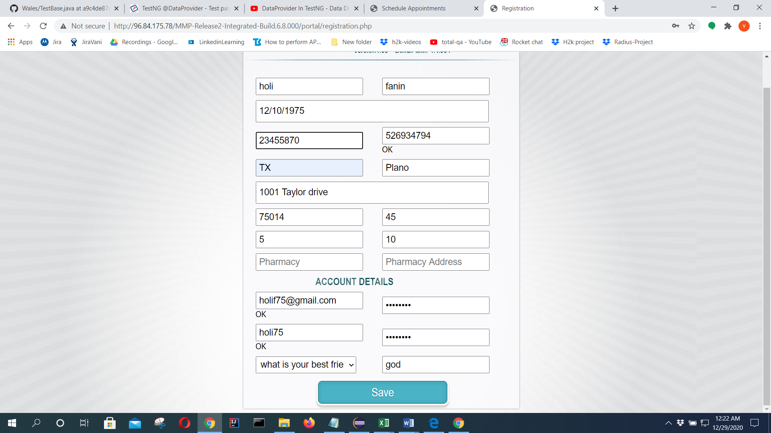

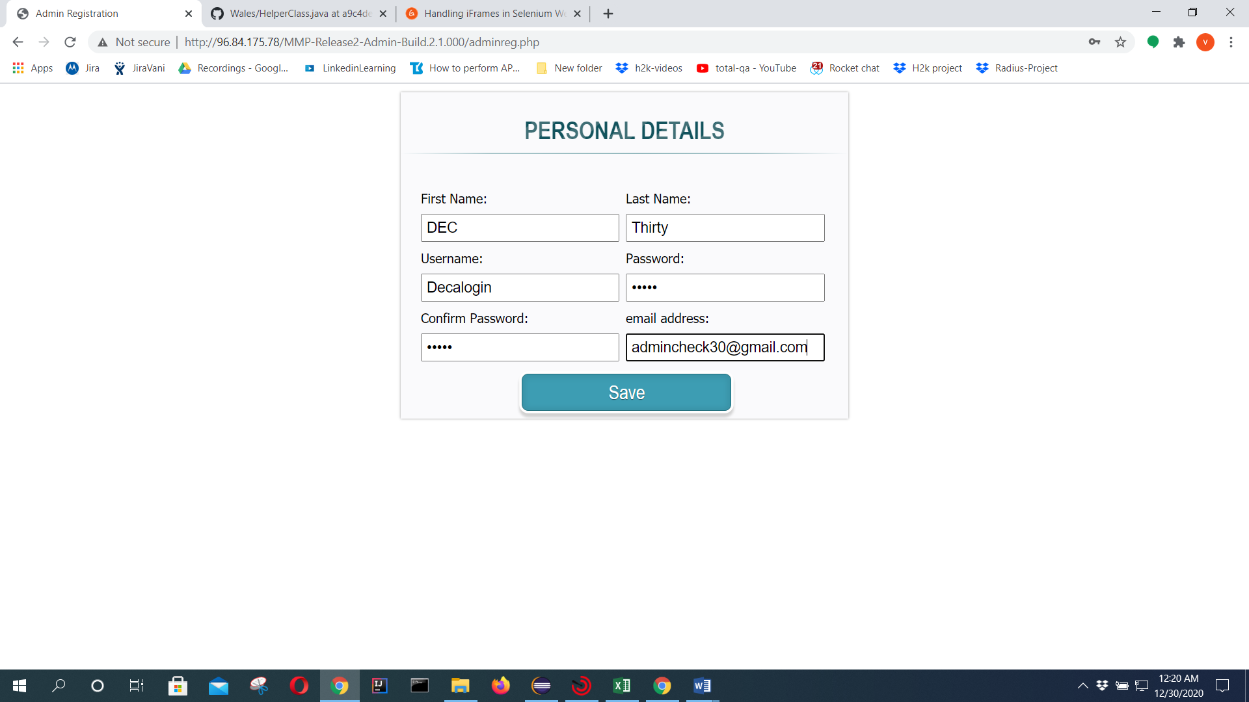

Dec12345